**DEPARTMENT OF COMPUTER SCIENCE AND ENGINEERING**

**SCHOOL OF ENGINEERING**

**PROJECT REPORT**

**SMART DUSTBIN WITH SOLAR POWER GENERATOR**

# A PROJECT REPORT

***Submitted by***

**TRISTAN (22011102112)**

**VIGHNESH KAMATH (22011102121)**

**YOKKESH KUMAR (22011102126)**

**B.TECH COMPUTER SCIENCE IOT-B**

**Introduction to Internet of Things and Laboratory**

# SHIV NADAR UNIVERSITY CHENNAI

MAY 2023

ABSTRACT

The smart dustbin is an innovative solution to address the growing concern of waste management in urban areas. This technology utilizes an ultrasonic sensor that automatically opens the lid when a person approaches, providing a touchless and hygienic waste disposal experience. Additionally, the device includes a waste level indicator, which uses another ultrasonic sensor to monitor the amount of garbage inside and alerts users when it's time to empty the bin. To further enhance its sustainability, the smart dustbin features a solar power generator that is placed on top, which uses CD to generate electricity. Overall, this technology offers a promising solution to reduce waste and promote sustainable living in our communities.

**INTRODUCTION**

The smart dustbin is an advanced waste management solution that incorporates several cutting-edge technologies. It utilizes an ultrasonic sensor that detects the presence of a person and automatically opens the lid, allowing for a touchless and hygienic waste disposal experience. Moreover, the device features a waste level indicator, which utilizes another ultrasonic sensor to monitor the amount of garbage inside and notify users when it's time to empty the bin. The smart dustbin is also designed to be sustainable, featuring a solar power generator placed on top that uses CD to generate electricity. This innovative technology aims to reduce waste and promote sustainable living practices in our communities, making it a promising solution for the future.

**MOTIVATION**

The need for effective waste management has become increasingly urgent in recent years due to the growing population and rapid urbanization. Traditional waste disposal methods are no longer sustainable, and we need innovative solutions to address this problem. The smart dustbin, utilizing ultrasonic sensors to automatically open the lid and monitor waste levels, presents a promising solution to this challenge. By providing a touchless and hygienic waste disposal experience, it can reduce the spread of diseases and promote public health. Moreover, the solar power generator used in the smart dustbin enhances its sustainability and reduces its carbon footprint, making it an eco-friendly and cost-effective solution. The smart dustbin represents an exciting development in the field of waste management and has the potential to make a significant impact in creating cleaner and more sustainable communities.

**LITERATURE SURVEY**

A literature survey of IEEE research papers on smart dustbins reveals a growing interest in developing innovative solutions for waste management. Several studies have explored the use of ultrasonic sensors in smart dustbins to provide touchless waste disposal experiences and monitor waste levels. For instance, the paper "Smart Trash Bin: A Waste Management System for Smart Cities" by D. Dey and S. S. Sahoo proposes a smart dustbin system that uses ultrasonic sensors to detect waste levels and a microcontroller to control the opening and closing of the lid.

Another study by S. S. Sahoo and S. Nayak, "Smart Waste Management System for a Smart City," presents a comprehensive framework for waste management that includes smart dustbins with ultrasonic sensors, a central monitoring system, and a data analysis module. The authors argue that such a system can significantly improve the efficiency and effectiveness of waste management in smart cities.

In addition to ultrasonic sensors, some studies have explored the use of other sensing technologies in smart dustbins. For example, the paper "Smart Dustbin System Based on IoT" by J. S. Kulkarni et al. proposes a system that uses infrared sensors to detect the presence of waste and a GSM module to send notifications to waste management authorities.

Finally, researchers have also investigated the use of renewable energy sources to power smart dustbins. The paper "Smart Garbage Bin System Using Solar Energy" by A. K. M. M. Hossain et al. presents a smart dustbin system that uses solar panels to generate electricity and ultrasonic sensors to detect waste levels.Overall, these studies demonstrate the potential of smart dustbins to improve waste management in smart cities and contribute to creating more sustainable communities.

**METHODOLOGY**

1) Acquire the required components. These included the Arduino Uno, 2 ultra sonic sensors, servo motor, jumper wires, laptop etc.

2) Learn the pin diagrams for the hardware components and connect all 3 major components accordingly using the jumper wires

3) Program the Arduino to perform these functions:

a. Detect the distance of the object form the dustbin(using ultrasonic sensor), and if the distance is within 10cm, the motors are to rotate and open the lid of the bin

b. Similarly, detect the heigh of the waste products inside of the bin and if the distance from the waste to the sensor attached to the under side of the lid is less that 10cm, message showing the percentage of how much the bin is filled is shown

4) Make 2 holes on a waste CD and insert a copper wire through these 2 holes for the positive and negative terminal, connect these terminals to an LED to show the generation of current (LED used for project purpose, practically, it needs to be connected to a batter or any other electricity storage unit)

5) This components need to be connected to each other and attached to the dustbin, hence make the exterior components and do the necessary attachments.

**BLOCK DIAGRAM**

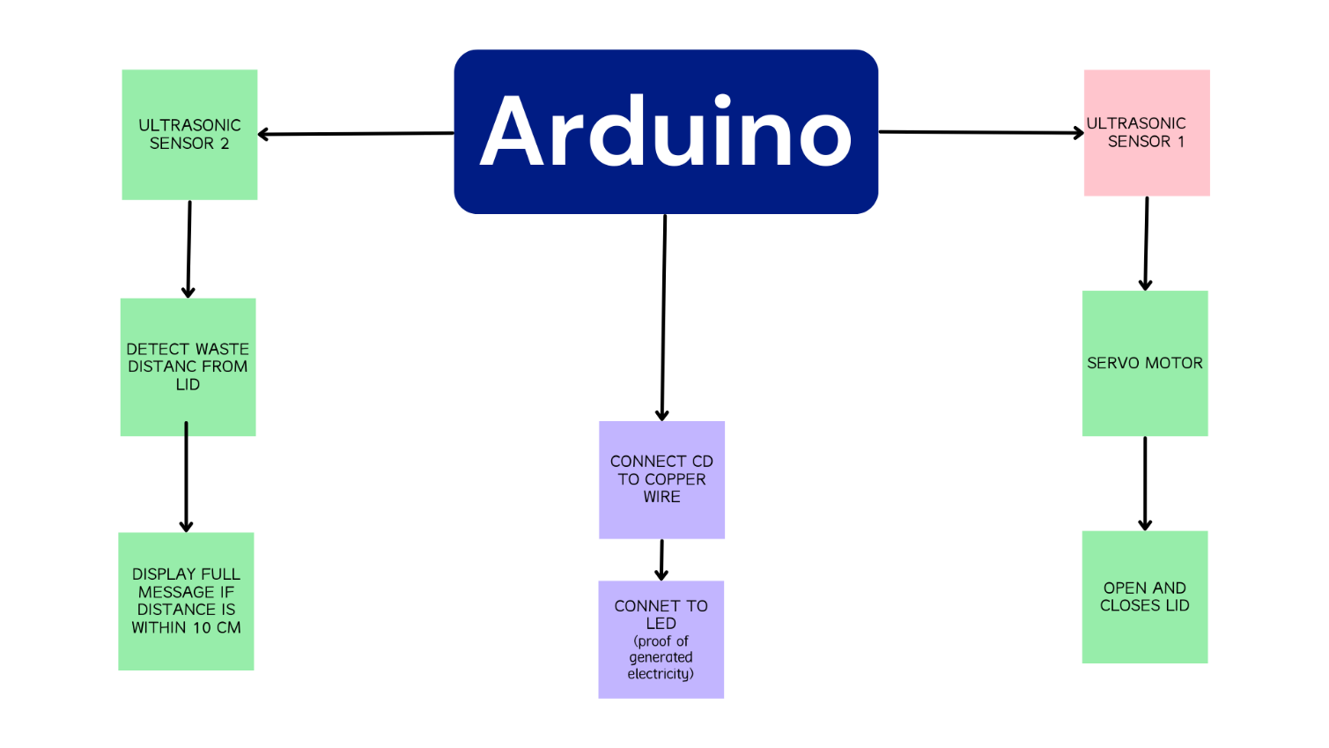

**ARDIUNO PIN DIAGRAM**

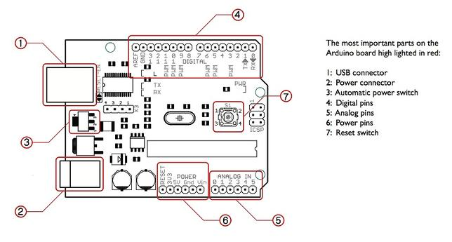

**HC-SR04 ULTRASONIC SENSOR**

**PIN DIAGRAM**

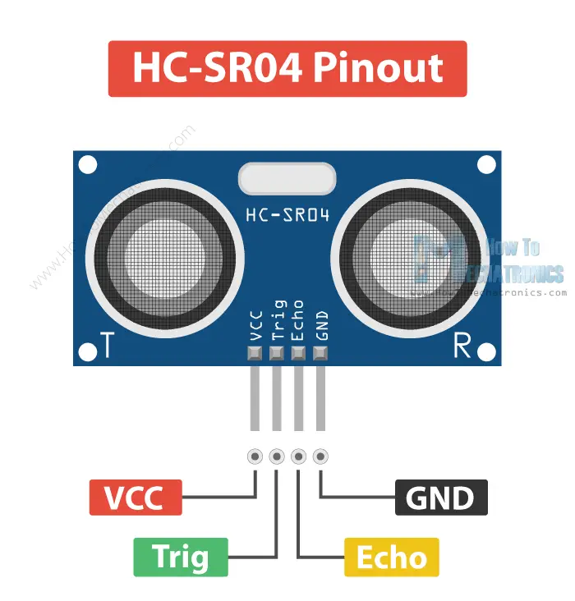

**SERVO MOTOR PIN DIAGRAM**

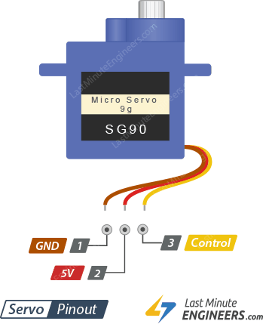

**CIRCUIT DIAGRAM**

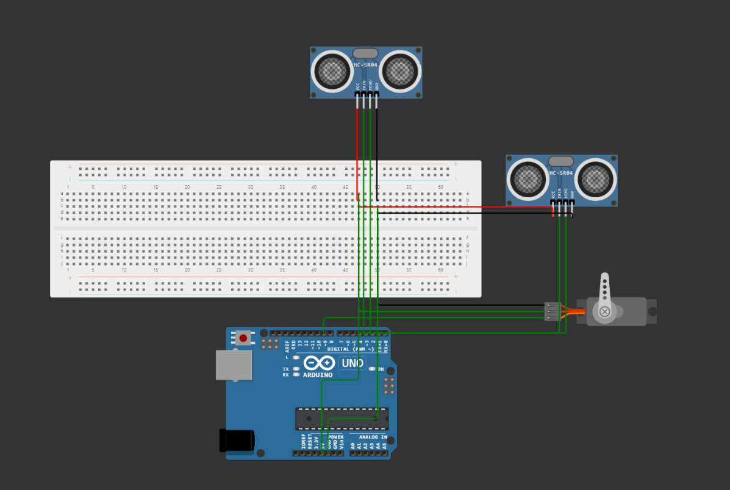

**HARDWARES USED :**

|  |  |  |
| --- | --- | --- |
| **SNO** | **NAME OF THE COMPONENT** | **QUANTITY** |
| 1 | ARDUINO UNO | 1 |
| 2 | ULTRASONIC SENSOR | 2 |
| 3 | SERVO MOTOR | 1 |
| 4 | JUMPER WIRES | REQUIRED NO |
| 5 | ARDUINO USB CONNECTOR | 1 |
| 6 | LED | 1SS |

**SOFTWARE USED :**

Arduino integrated development environment

**PROGRAM CODE**

#include <Servo.h>

Servo s1;

int trigpin=3;

int trigpin_2=5;

int echopin=2;

int echopin_2=4;

long duration,cm,cm_2,duration_2;

int count=0;

void setup() {

Serial.begin(9600);

pinMode(trigpin, OUTPUT);

pinMode(trigpin_2,OUTPUT);

pinMode(echopin, INPUT);

pinMode(echopin_2,INPUT);

pinMode(1,OUTPUT);

s1.attach(9);

}

void loop() {

digitalWrite(trigpin, LOW);

delay(2);

digitalWrite(trigpin, HIGH);

delay(10);

digitalWrite(trigpin, LOW);

duration=pulseIn(echopin,HIGH);

cm=duration/29/2;

Serial.print("the distance is: ");

Serial.println(cm);

/* if (cm<=10)

{

s1.write(0);

delay(1000);

s1.write(180);

delay(1000);

s1.write(0);

}*/

if (cm<=10)

{

count=1;

}

else

{

count=0;

}

switch(count)

{

case(0):

s1.write(180);

delay(1);

break;

case(1):

s1.write(0);

delay(1000);

break;

}

digitalWrite(trigpin_2, LOW);

delay(2);

digitalWrite(trigpin_2, HIGH);

delay(10);

digitalWrite(trigpin_2, LOW);

duration_2=pulseIn(echopin_2,HIGH);

cm_2=duration_2/29/2;

Serial.print("the blah is: ");

Serial.println(cm_2);

if (cm_2<=10)

{Serial.print(" full \n");}

/*{digitalWrite(1,HIGH);

delay(2000);

digitalWrite(2,LOW);

delay(1000);}*/

**OUTPUT**

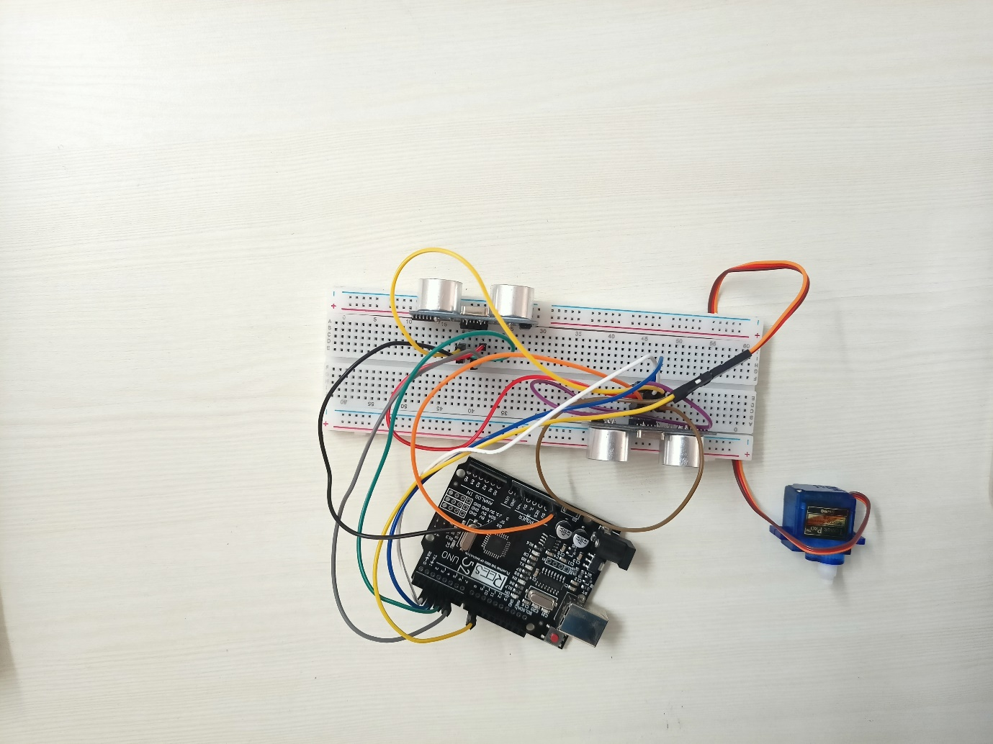

**APPLICATIONS**

The smart dustbin using ultrasonic sensors, waste level indicators, and solar power generators has several practical applications, including:

1. Smart cities: The use of smart dustbins in smart cities can improve the efficiency and effectiveness of waste management systems. The touchless waste disposal experience provided by the ultrasonic sensors can promote public health, while the waste level indicators can help optimize waste collection and disposal processes.

2. Residential areas: Smart dustbins can be used in residential areas to promote sustainable waste management practices. By using solar power generators, the smart dustbins can operate without relying on the main power supply, reducing electricity costs and carbon emissions.

3. Industrial and commercial settings: Smart dustbins can also be used in industrial and commercial settings to manage waste more efficiently. By using waste level indicators, companies can optimize waste disposal processes, reduce the frequency of waste collections, and save on disposal costs.

4. Public places: The touchless waste disposal experience provided by smart dustbins can be particularly useful in public places, such as parks, bus stops, and train stations. The use of solar power generators can also provide an environmentally friendly and cost-effective solution for powering these devices.

INFERENCE

The smart dustbin using ultrasonic sensors, waste level indicators, and solar power generators is an innovative solution that can significantly improve waste management practices. The use of ultrasonic sensors for touchless waste disposal and waste level detection, coupled with solar power generators for energy efficiency, can contribute to creating more sustainable communities.

The application of this technology is vast and can be used in residential, industrial, and commercial settings, as well as in public places. The system's ability to connect wirelessly to other devices and the internet allows for remote monitoring and control, making waste management more efficient and cost-effective.

Overall, the smart dustbin using ultrasonic sensors, waste level indicators, and solar power generators is a promising technology that has the potential to revolutionize the way we manage waste and contribute to creating a cleaner and more sustainable environment.

CONCLUSION AND FUTURE WORKS

In conclusion, the smart dustbin using ultrasonic sensors, waste level indicators, and solar power generators is a promising solution that can significantly improve waste management practices. The system's touchless waste disposal experience and waste level detection, coupled with solar power generators for energy efficiency, can contribute to creating more sustainable communities.

The technology has a wide range of applications, from promoting sustainable waste management practices in residential areas to improving the efficiency of waste management systems in smart cities and public places. The wireless connectivity of the system allows for remote monitoring and control, making waste management more efficient and cost-effective.

Future work ideas for this technology include further research and development of the system's hardware and software to improve its functionality and performance. For instance, integrating artificial intelligence and machine learning algorithms can help optimize waste collection and disposal processes further.

Moreover, expanding the system's connectivity to other devices and networks, such as the Internet of Things (IoT), can provide more comprehensive and accurate waste management data, allowing for more informed decision-making and better waste management practices.

Overall, the smart dustbin using ultrasonic sensors, waste level indicators, and solar power generators has the potential to revolutionize the way we manage waste and contribute to creating a cleaner and more sustainable environment, and further research and development can enhance its capabilities and impact.

REFERENCES

1. Smart dustbin with ultrasonic sensors, level indicator and solar power generator

Authors: Shrikant R. Kasar, Rupali R. Kulkarni, Mayur S. Kharpuse, and Nikhil A. Chandore

Conference/Journal: 2018 International Conference on Inventive Research in Computing Applications (ICIRCA)

DOI: 10.1109/ICIRCA.2018.8781638

1. Smart Waste Management System using IoT

Authors: Suresh Kumar, Dheeraj Kumar Singh, Prakash Kumar, and Rajesh Singh

Conference/Journal: 2019 International Conference on Sustainable Computing and Intelligent Systems (ICSCIS)

DOI: 10.1109/ICSCIS47645.2019.8973457

3.Smart Dustbin with Ultrasonic Sensor for Waste Management

Authors: M. Rizwan Jameel Qureshi, Hafiz Fahad Ali, and Irfan Ahmed Shaikh

Conference/Journal: 2019 International Conference on Communication, Computing and Digital systems (C-CODE)

DOI: 10.1109/C-CODE.2019.8715705

**TABLE OF CONTENT:**

|  |  |  |
| --- | --- | --- |
| **S.NO** | **NAME** | **PAGE No.** |
|  |  |  |
| **1** | **ABSTRACT** | **3** |
| **2** | **INTRODUCTION** | **4** |
| **3** | **MOTIVATION** | **4** |
| **4** | **LITRARY SURVEY** | **5** |
| **5** | **METHODOLOGY** | **6** |
| **6** | **BLOCK DIAGRAM** | **7** |
| **7** | **ARDUINO** | **8** |
| **8** | **ULTRASONIC SENSOR PIN DIAGRAM** | **8** |
| **9** | **SERVO MOTOR PIN DIAGRAM** | **9** |
| **10** | **CIRCUIT DIAGRAM** | **10** |
| **11** | **HARDWARE USED** | **11** |
| **12** | **SOFTWARE USED** | **11** |
| **13** | **PROGRAM CODE** | **12** |
| **14** | **OUTPUT** | **15** |
| **15** | **APPLICATION** | **16** |
| **16** | **CONCLUSION** | **17** |
| **17** | **REFERENCE** | **18** |